**Django ORM**

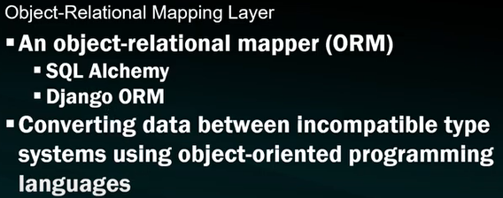

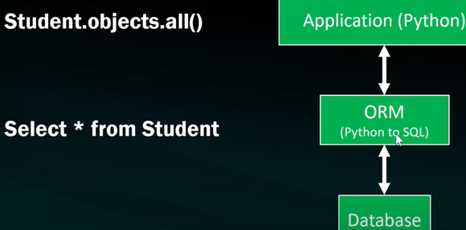

Here in student.objects.all() => student is the table name.

Objects is the manager. Manger is a Django class provides the interface b/w database query operations and Django model. All() is all the data from the table.

